Anne Greeley

Cabaret Voltaire

The Cabaret Voltaire, housed within the Holländische Meierei bar at Spiegelgasse 1 in Zürich’s Niederdorf district, was the original breeding ground and hub of the Zürich Dada movement. Co-founded in February 1916 by German writer and performer Hugo Ball and professional cabaret singer and poet Emmy Hennings (Ball’s lover and future wife), the venue was conceived as a *künstlerkneipe* [artists’ local] for the young artists of Zürich and promoted as a “centre for artistic entertainment.” Its appellation, however, bespoke a more political objective: it was named after the eighteenth-century Enlightenment philosopher and aggressive social reformer, Voltaire, who, in his satirical novel *Candide,* had derided the religious and philosophical optimism of the time. The cabaret was thus envisioned by Ball as a kind of modern Candide, a stage from which to protest overly positive appraisals of the unfolding First World War and the ostensibly rational society which had produced it. On its opening night, February 5, the cabaret drew future Dadaists and core cabaret performers Marcel Janco, Tristan Tzara, and Hans/Jean Arp. They were soon joined by Richard Huelsenbeck at Ball’s behest.

The cabaret became notorious for chaotic and brutal performances which, although stylistically diverse, were united by two basic, complementary aims: to protest the madness of the war and the society engaged in it by depicting madness in sharp relief, and to return art to its primordial origins through an anti-rational embracing of primitivist forms of expression.

Modelled on prototypes in Berlin and Munich, the cabaret initially operated as a traditional variety theatre, offering an eclectic mix of modernist and popular entertainment. Following Huelsenbeck’s arrival, it took on an increasingly anarchic tone, evolving rapidly into the “gladiatorial” arena through which the incipient Dada group enacted its attack upon Western norms and culture. In July 1916, after a rigorous five months, the cabaret closed its doors, due in part to diminishing revenue at the bar, but largely to the exhaustion of the performers. In March 1917, the Dada group embarked upon a second phase of activity at the Galerie Dada (formerly, the Galerie Corray) at Bahnhofstrasse 19.

Experimental forms of performance at the Cabaret Voltaire included Bruitist and Simultaneous poems, premised on Futurist principles of *bruitisme* [noise-music] and simultaneity (inherited from Cubism); abstract or phonetic sound poems rooted in Wassily Kandinsky’s spiritually-inflected theory of abstraction; and primitivist performances described as “chants nègres,” featuring poems composed in an imaginary, pseudo-African language set to rhythmic so-called “negro” drumming and accompanied by “primitive” masks and costumes.

References and Further Reading

(1995) Blago Bung Blago Bung Bosso Fataka!: The First Texts of German Dada, ed. and trans. M. Green. London: Atlas Press.

Pichon, B. and Riha, K., eds. (1996) Dada Zurich: A Clown’s Game from Nothing, vol. 2 of the series, Crisis and the Arts: The History of Dada, ed. S.C. Foster. New York: G.K. Hall & Co.

Berghaus, G. (2005) “Dadaism” in Theater, Performance, and the Historical Avant-Garde. New York: Palgrave McMillan.

Kuenzli, R., ed. (2006) Dada. Phaidon: New York.

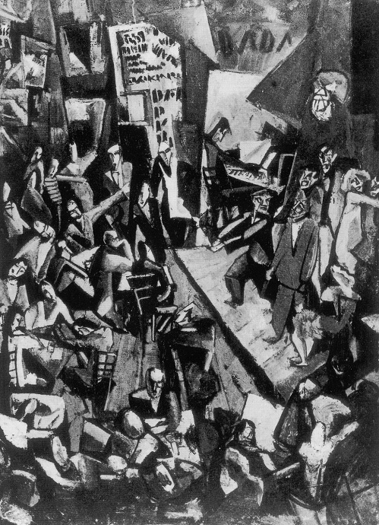

Marcel Janco, *Cabaret Voltaire*, 1916 (photograph of a lost work)

Copyright: © ADAGP, Paris, and DACS, London 2003. Kunsthaus Zürich.

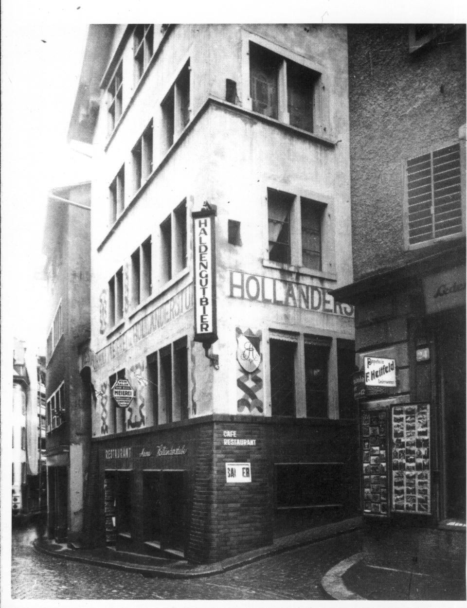

Cabaret Voltaire, Zürich, 1935

Copyright: Kunsthaus Zürich and International Dada Archives